OPPS

1.what is OPPS ?

it is a programming technique where thing are revolved around object (object is entity which will going to have its property or state and its behaviour ) in order to incerase the readeability of my programm , mangaebility and extensiblity of programm .

2.what is class ?

class is user define data types

3.Acess Modifires in class ?

1.public : in public mode we can ascess the data memeber anywhere inside the class or outside of class through its object .

2.private

3.procted

4.Copy constructor

hero ramesh(56,”fighter);

hero suresh(ramesh);

5.Destructor

1. Encapsulation

encapsulaton is wraping of data mebemer and fuction .

2.fully encapsulation : where all the data memeber is private.

why encapsulation :

i)hiding data member (data security)

ii)with the help of encapsulataion we can make class read only

2,Inheritance

inheritance is way of inheriting propoerty or state from the parent calss . exg : HUMAN CLASS having height,wieght,age , MALE CALSS , FEMALE CLASS

implementation :

class male : acess modifier parent class{};

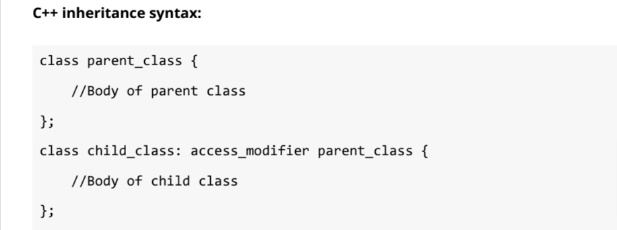

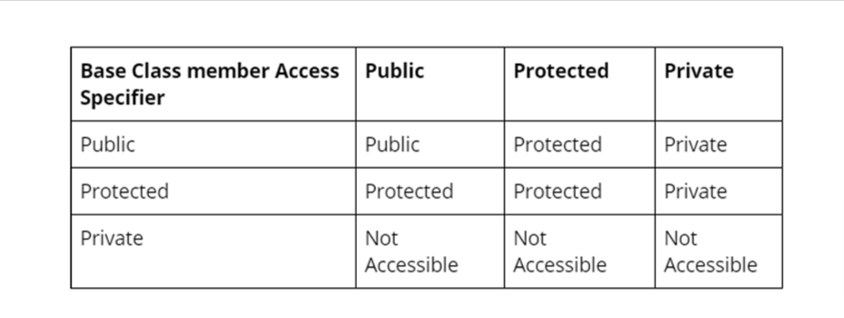

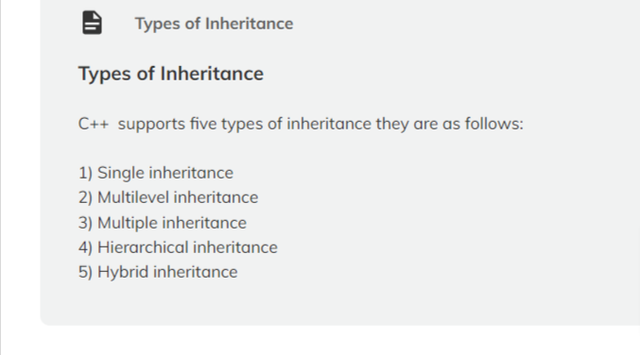

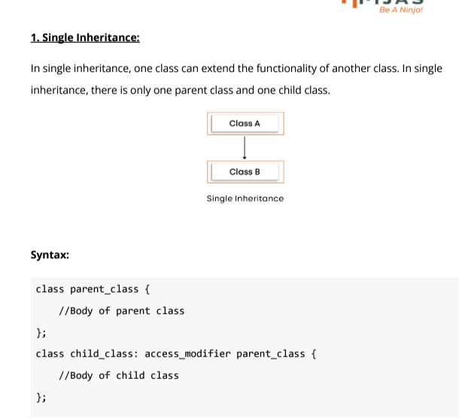

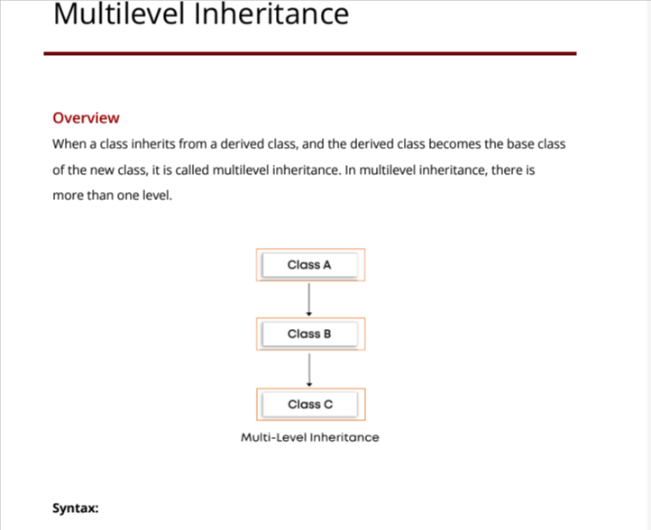

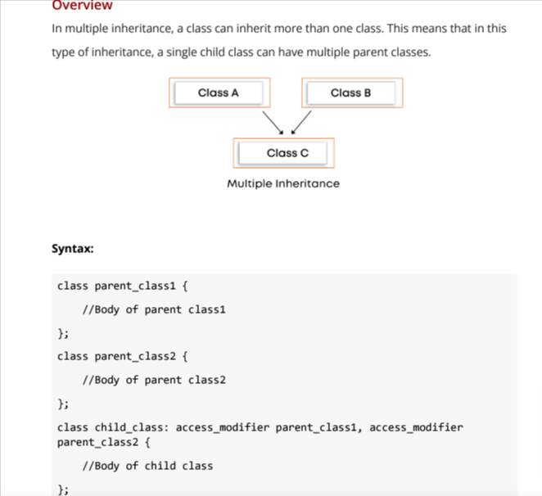

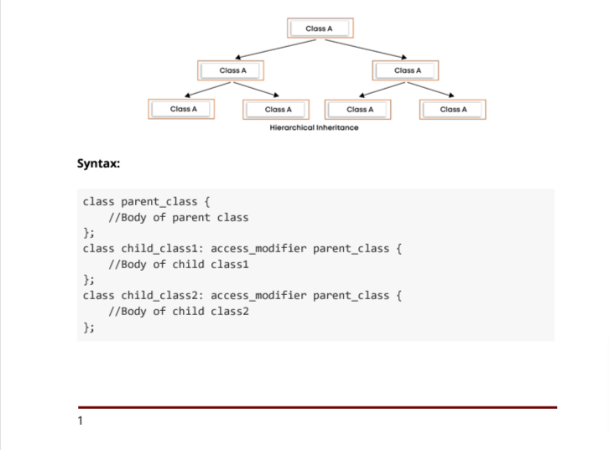

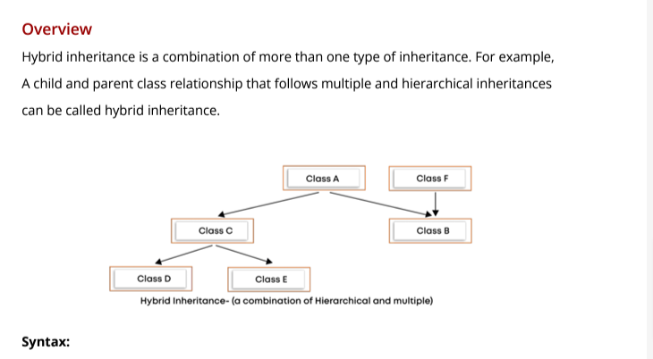

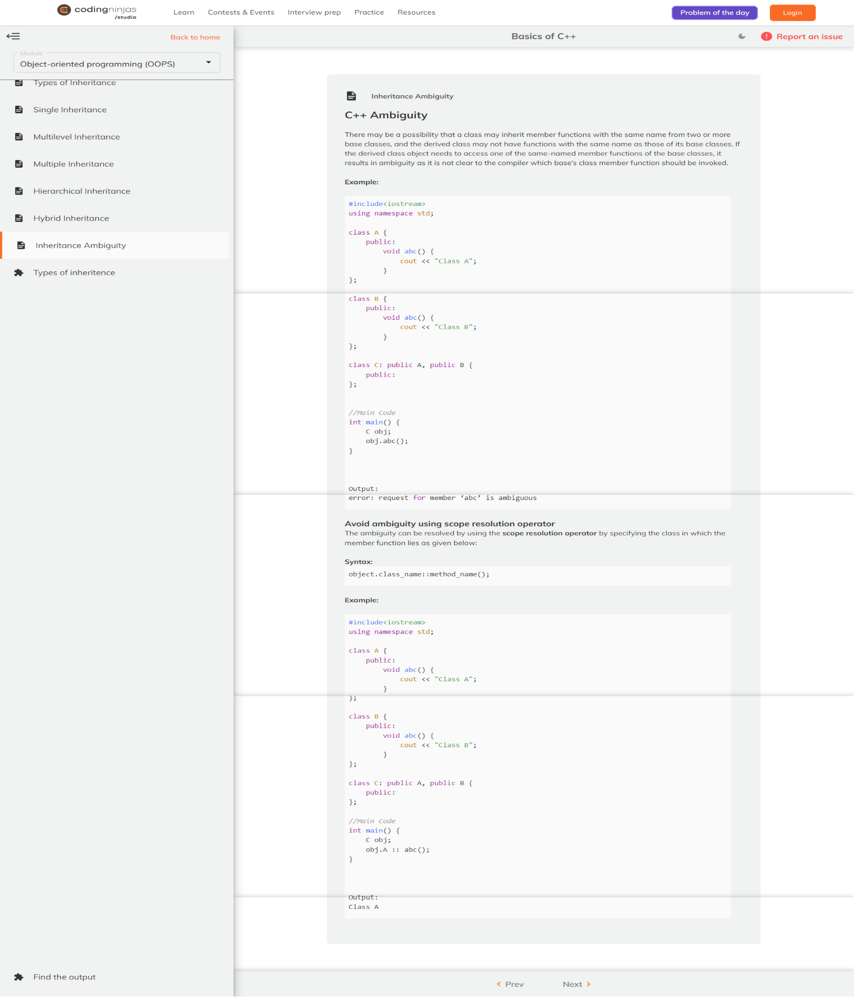

3.Polymorophism

polymorphsim is technique is opps where we can use function with the same multiple time by changing the input paramenter

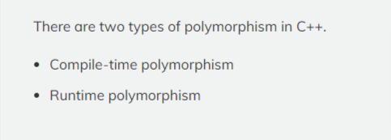

1.compiler time polymorphism

a)funcition overlaoading

i)we have diffrent dirrent method ot overlaod a fuction by chaning the arugment .

b)operator overlaoding

2.Runtime polymoriphism

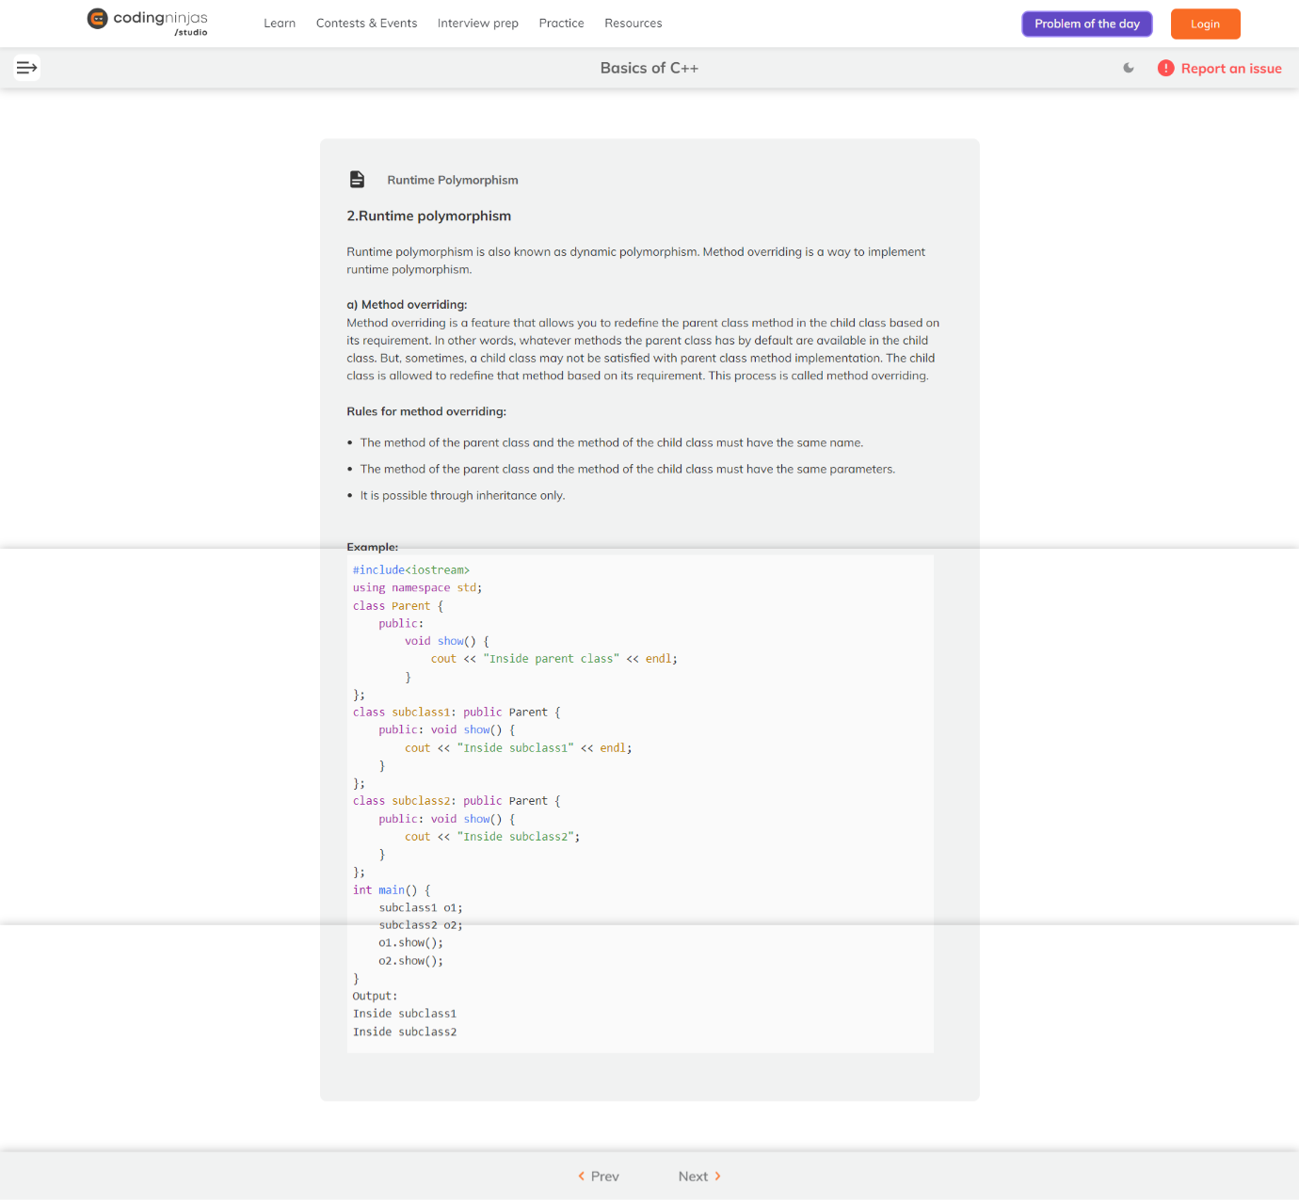

4.Abstraction

abstraction is implentaion hiding

diffrence between encapsulation and abstaraction :

encapsulation : information hiding

abstraction : implementation